Construction Guide for a Tuning Table
using the
AKKOtune compact DIY Kit

The Goal
The AKKOtune compact DIY kit (DIY = Do it yourself) is designed to enable skilled DIYers to build a fully functional tuning table with the following features:
- Airflow
  - o with adjustable pressure
  - o uniform
  - o unlimited volume
- Pressure gauge in mbar
- Reversible airflow direction
- Easy operation
- Connector for foot switch

The Operating Principle
The blower generates an airflow that enters the housing from the rear and builds up positive pressure in a pressure chamber, similar to a bellows. Conversely, the blower draws air out of the pressure chamber and expels it from the rear of the housing. In this way, the pressure chamber functions like a bellows when the accordion bellows is pushed or pulled.

The Technology
The blower, which has a maximum static pressure of 1,260 Pa at an airflow rate of 56,8 CFM, is controlled via pulse-width modulation (PWM). It operates on a 12 V DC voltage. The blower is turned on and off using the rs and £ buttons. This is achieved by changing the pulse width, which controls the blower’s speed: 100% = full speed, 0% = stop. Pulse width control is handled by a microprocessor built into the BlowBox module. The direction of the airflow —blowing or suction— is determined by a valve controlled by a digital servo. This is also managed by the microprocessor.
Pressure is measured directly inside the pressure chamber by a differential pressure module with a measurement range of ±20 mbar (millibars). It is connected to the control panel by a cable and measures the difference between the pressure inside the pressure chamber and the ambient pressure (hose to the rear wall).

Operation
The control panel on the front panel features control and display elements:
- LED: 12 VDC from the external power supply
- LED: 5 V control voltage for the microprocessor
- LED: 8.4 V voltage for the digital servo
- Digital air pressure gauge
- Rotary knob for powering on the system and adjusting pressure
- Buttons for starting blow (PUSH) and suction (PULL) and STOP
- Switch for reversing the pressure/draw function
- Switch for selecting the foot control: 3 pedals or 1 pedal
- Fuse holder on the right side: 6.3A fuse, 5x20mm
- Connection jack for optional foot control on the left side
BlowBox Module
The BlowBox module includes:
- the blower
- the control board:
  - microprocessor
  - voltage converter for servo voltage (8.4V)
  - fuse
  - connections for blower and servo

- digital servo (HV 8.4 V, 20 kg)
- valve mechanism
- sound-dampening material
- mounting subfloor
- rubber buffer mounting on the mounting subfloor
- airflow paths:
  - to/from the outside (lower part of the housing)
  - into/out of the pressure chamber
(through the mounting subfloor)

- connection cable to the control panel
- pressure sensor module on the mounting subfloor
  - airtight feed-throughs:
    - cables of the pressure measurement module
    - measuring hose to the rear or side wall

The module is suspended in a cutout in the mounting subfloor along with the intermediate panel itself and secured airtight with screws. Holes and a circumferential foam gasket are provided along the edge of the mounting intermediate panel for this purpose. The cable of the pressure measurement module, which can be screwed into place in two positions on the mounting subfloor, is routed downward in an airtight manner. The silicone hose connected to a port on the pressure sensor is routed to the outside via a special feed-through. To do this, a 10-mm hole must be drilled in the rear or side wall.
Power Supply
To prevent dangerous voltages inside the device, all AKKOtune systems are powered by an external power supply.
The line voltage can range from 100 VAC to 240 VAC; the output voltage is always 12 V DC. Depending on the version of the AKKOtune system, the power rating is 60 W or 80 W.
The coaxial connector has an outer diameter of 5.5 mm and an inner diameter of 2.5 mm. The corresponding jack is mounted on a 50-mm-long cable (included in the kit), which has a connector at the other end for connecting to the control panel. The jack is mounted in a 12-mm hole in one of the housing walls. The connector is routed through the cable mounting hole in the front panel.
Construction of the Enclosure
In the following, we will focus on building the tuning table enclosure. The actual construction is the responsibility of the customer who wishes to use the kit for an “AKKOtune compact DIY” system to build their own tuning table. The design shown below is an example.
You will need some tools:
- Drill, 30mm Forstner drill bit, 10mm or 3/8” drill bit
- TX10 screwdriver (to screw the control panel to the front panel)
- Jigsaw for cutting out the BlowBox module space in the intermediate shelf

All other tools are part of the standard equipment of an accordion repair shop.
Example for a Tuning Table Enclosure

This is an easy job that can be completed in a few hours.

Basically, the cabinet consists of 7 panels (at least 0,5" thick),
the example uses 12mm MDF panels:
  - 1 bottom panel 524 x 324 mm
When using other panel thicknesses these dimensions need to be adapted.
  - 1 top panel or worktop 524 x 324 mm
  - 2 side panels 150 x 300 mm
  - 1 back panel 150 x 524 mm
  - 1 front panel 150 x 524 mm
  - 1 intermediate shelf 500 x 300 mm
For simplicity's sake, these panels are simply joined end-to-end. That is, the side panels are screwed between the front and back panels. The intermediate shelf (cut-out 400 x 200 mm) rests on a perimeter strip. The strip and the intermediate shelf can be glued or screwed to these panels.
Since the mounting subfloor has external dimensions of 420 mm x 240 mm, the intermediate shelf should measure at least 500 x 300 mm. The height between the bottom panel and the top panel should be more than 140 mm; the height between the top edge of the intermediate shelf and the bottom panel should be at least 105 mm.
Air vent openings with a total cross-sectional area of at least 1,800 mm² must be provided in the rear wall. The air moved into and out of the pressure chamber by the blower requires this equalization.
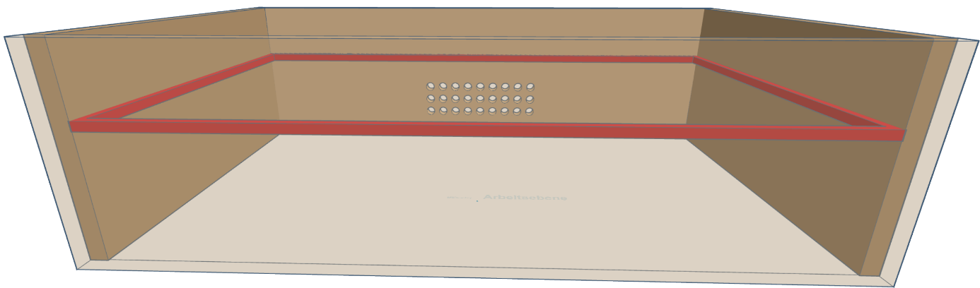
back panel
side panel
side panel
perimeter strip
Sketch showing side panels and back panel; front panel shown as transparent
air vent openings
front panel

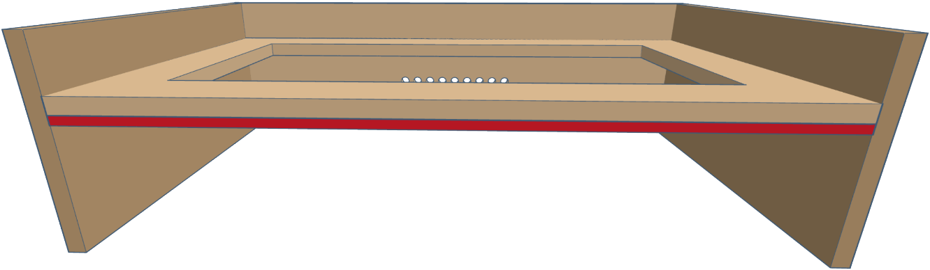
Intermediate shelf
front panel not shown

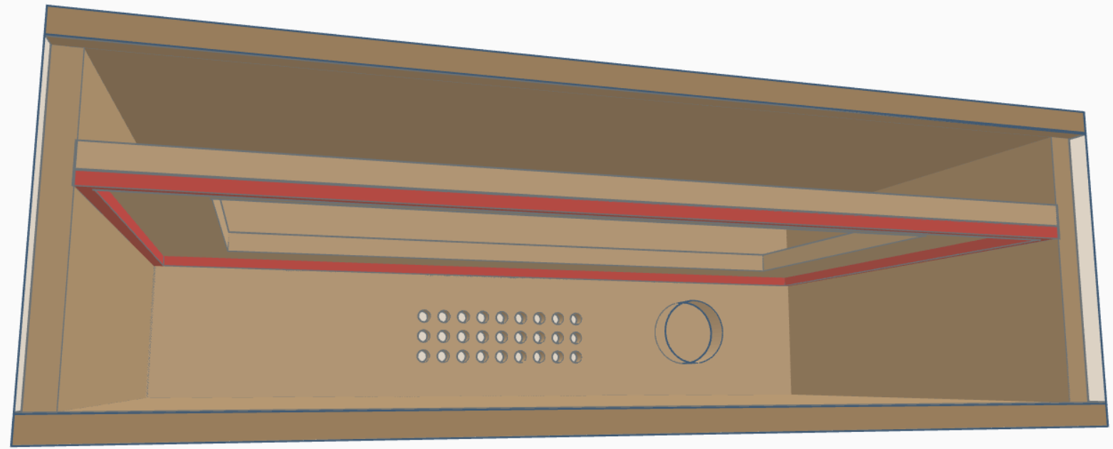
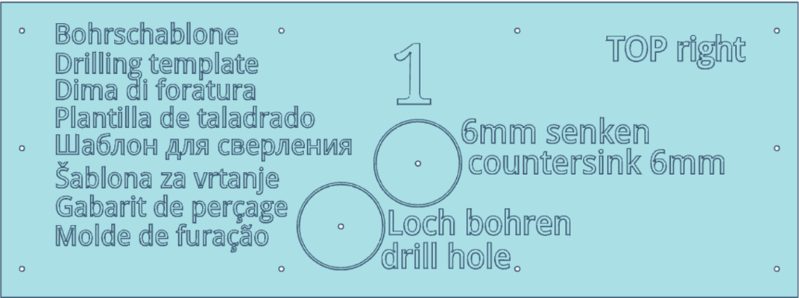
Drilling Template 1
for control panel with PCB1
All cables are routed
Through the hole

The recess provides space for parts of PCB1 that protrude toward the back.
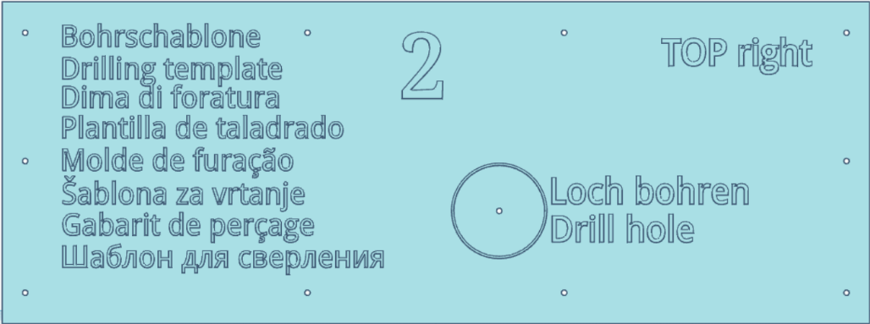
Drilling Template 2

for control panel with PCB2
(modified)

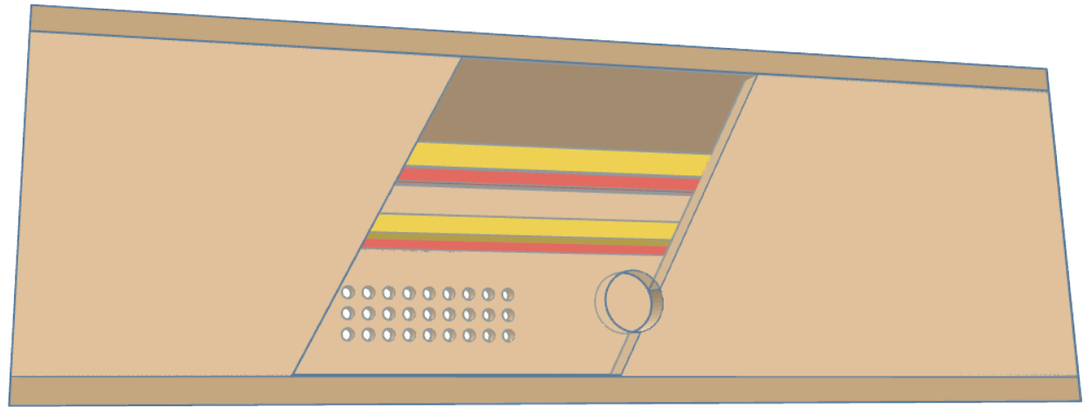

Enclosure with trasparent
front panel

The front panel has a cable
hole made with template 2

Front panel shown partly
transparent.

The drilling templates are included in the kit (each designed to fit the control panel circuit board) and are placed in the center of the front panel.
The holes for airflow compensation should be drilled at your discretion. The area of the case beneath the intermediate shelf does not need to be airtight to the outside. This also applies to the 12-mm hole drilled for the power supply jack.
The BlowBox module can now be inserted into the cut-out in the intermediate shelf and secured with screws. The cables are fed through the 30-mm hole in the front panel. Suitable sound-dampening material can be packed around the BlowBox. Make sure there is sufficient space for airflow between the air inlet/outlet at the end of the BlowBox and the airflow compensation openings.
4-mm holes have already been drilled along the edge of the mounting subfloor for fastening it to the intermediate floor. The edge is fitted with a sealing strip.
Next, the bottom plate is screwed to all walls from below. When installing the top plate/worktop, keep in mind that this should create a pressure chamber. The intermediate shelf must be glued airtight to all walls. To ensure the pressure chamber is airtight except for the vent hole, a self-adhesive sealing strip (included in the kit) is applied to the upper edge of the walls.

The second port of the differential pressure sensor is connected to ambient pressure via a hose; to do this, drill a 10-mm hole for the airtight feed-through below the work surface in the back or side wall. Connect the hose to this hole.
Use the drilling templates to drill the 2-mm mounting holes for the control panel; the TX10 screws needed for this are included in the kit. Before doing so, connect the 4 cables to the control panel:
- BlowBox control cable,
16-wire ribbon cable with IDC connector
- BlowBox DC cable,
2-wire with a female connector
- Cable from the power supply jack,
2-wire cable with a female connector
- Pressure Sensor cable,
  - 3-wire cable with a female connector for PCB1
  - 6-wire ribbon cable with IDC connector for PCB2

Final Steps
Once the worktop has been securely screwed down to create an airtight seal, the appliance is ready for use.
Of course, any DIY enthusiast is free to create their own cabinet design. For example, instead of using strips, the middle shelf can be glued into a circumferential groove, as can the joints between the sides.
It’s helpful if the bottom panel remains removable. As shown in the YouTube video, a worktop that extends beyond the front is also possible.

Additional Information
Watch the video https://youtu.be/8FfnXLabpN8 at YouTube for further information and guidance.
If you are interested in interchangeable blowhole inserts, we would be happy to provide assistance with that.

